**FAULT DETECTION AND ISOALTION**

**01795967**

**Zhenzhe Han**

**• Initial data:**

For given matrix $\left[\begin{aligned}A B B_{f} B_{d} \\ C 0 D_{f}{ D}_{d}\end{aligned}\right]=\left[\begin{matrix}-2 & 1 & 1 \\ 4 & 0 & 6 \\ -5 & 0 & 1\end{matrix} \begin{matrix}4 & -4 \\ -4 & 0 \\ 3 & 2\end{matrix}\right]$

Consider A=-2, B=1, $B_{f}$ =1, $B_{d}$ = [4 -4], C= $\left[\begin{aligned}4 \\ -5\end{aligned}\right]$, $D_{f}$ = $\left[\begin{aligned}6 \\ 1\end{aligned}\right]$, ${ D}_{d}$ = $\left[\begin{matrix}-4 & 0 \\ 3 & 2\end{matrix}\right]$

**• Assumptions:** Assumption (3) and (4) are satisfied.

**• Initial computation:** Effecting the svd of $D_{f}$ gives:

**• Defined Data:**

1. $D_{f}^{†}$ = [0.16,0.027] and $D_{f}^{⊥}$ = [-0.1644,0.9864].
2. The matrices are given as

$\left[\begin{matrix}A_{1} & B_{1} \\ C_{1} & D_{1} \\ C_{2} & D_{2}\end{matrix}\right]=$ $\left[\begin{matrix}-2.5135 & 4.5676 & -4.0541 \\ 0.5135 & -0.5676 & 0.0541 \\ -5.5896 & 3.6168 & 1.9728\end{matrix}\right]$

**• Main Computation:** The LMI solver (mincx) gives

[P, Z, R, S] = [−0.0071, 0.0370, −5.2246, 0.1147], γo = 0.3192.

**• Finally,**

L = [0.6968, -5.1806], H = [0.1433, 0.1401].

**Check for the stability of A+LC**

Eigenvalue of A+LC is 26.6899 which is unstable.

L should be modified by solving a Riccati equation.

Assuming (A + LC, HC) is detectable

let $X=X'≥0$ be the solution to the ARE

$$(A + LC)X + X(A + LC) ' - X(HC) ' (HC)X = 0$$

such that $A + LC - X(HC) ' (HC)$ is stable.

Redefine $L := L - X(HC) 'H$

Finally, L = [60.7578,53.5442], H = [0.1433, 0.1401].

Use Simulink to provide simulation diagrams for the same fault and disturbance scenarios as in the lecture notes: amplitude of fault is 2 at 6s, amplitude of disturbance 1 is 2 at 2s and amplitude of disturbance 2 is 2 at 4s. u(t) is a step function with amplitude 1.

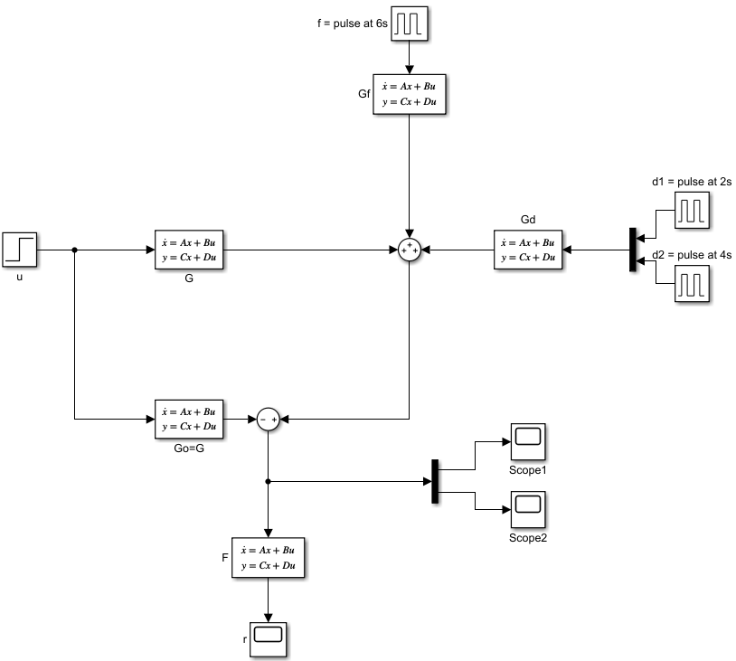

The scopes show that

Scope 1:

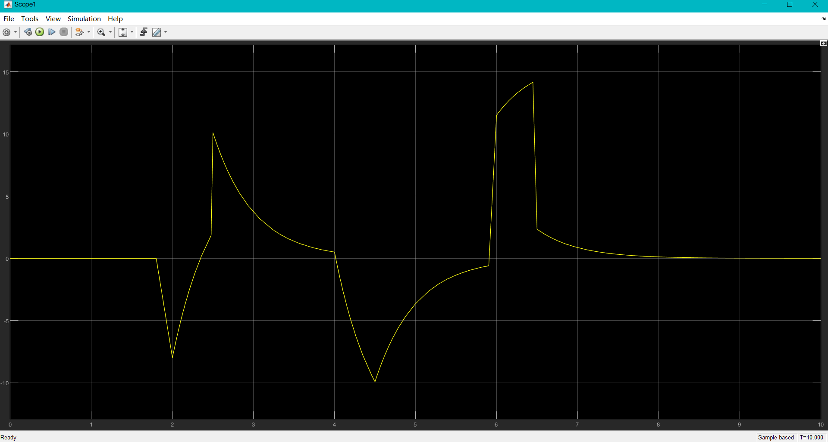

Scope 2:

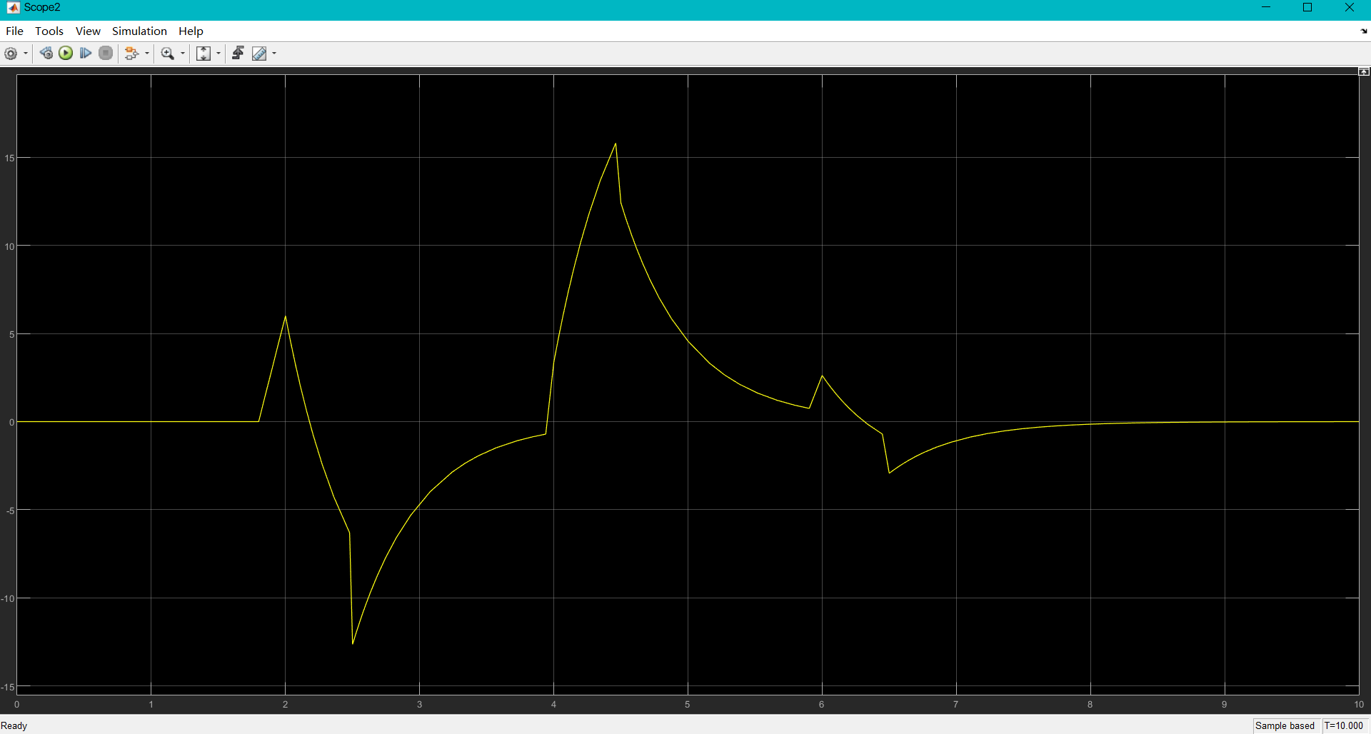

r(t):

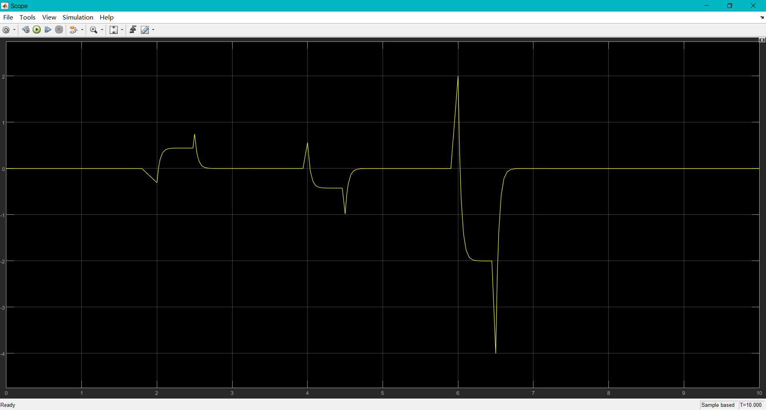

For scope1 and scope2 there exists mixed signal (f, d1, d2). However, diagram of r shows that d1 and d2 are reduced and f is enlarged after F. If we set detectable threshold at ±1.5 (ignore the signal which absolute value lower than 1.5), the disturbance at 2s and 4s will not be detected by the system. The diagram shows that there exists a fault at 6s.

**Experiment with difference scenarios to demonstrate the effectiveness of the FD algorithm.** Set fault: f = pulse at 2s with amplitude 2, disturbance: d1 = pulse at 2s, d2 = pulse at 2s. Amplitude of all disturbance signals are 2.

Scope 1:

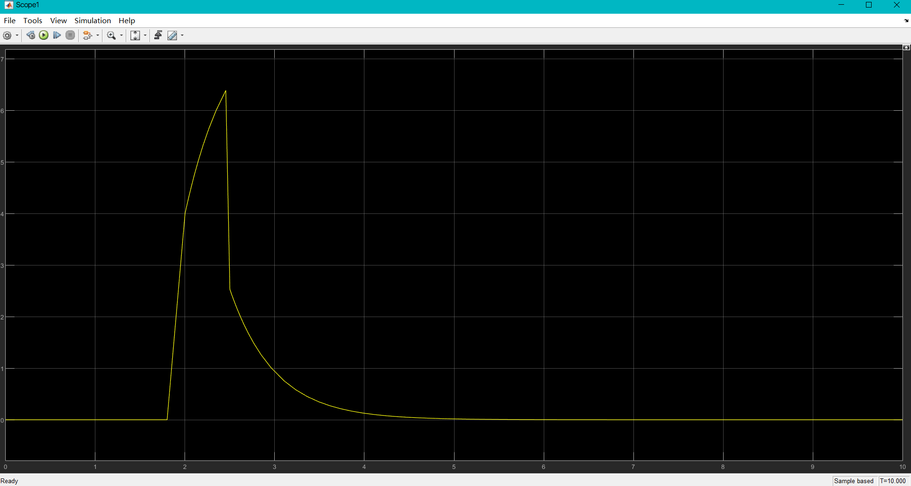

Scope 2:

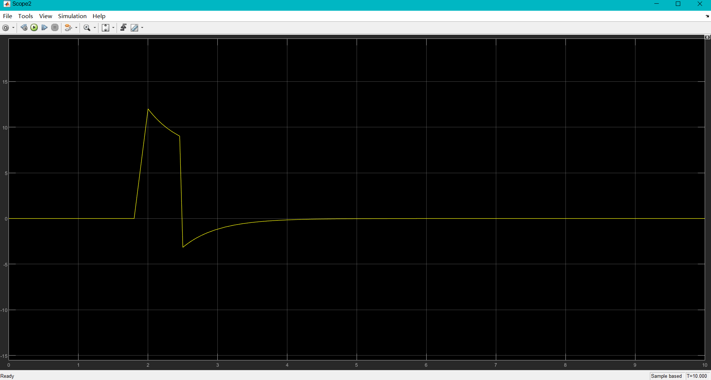

r(t):

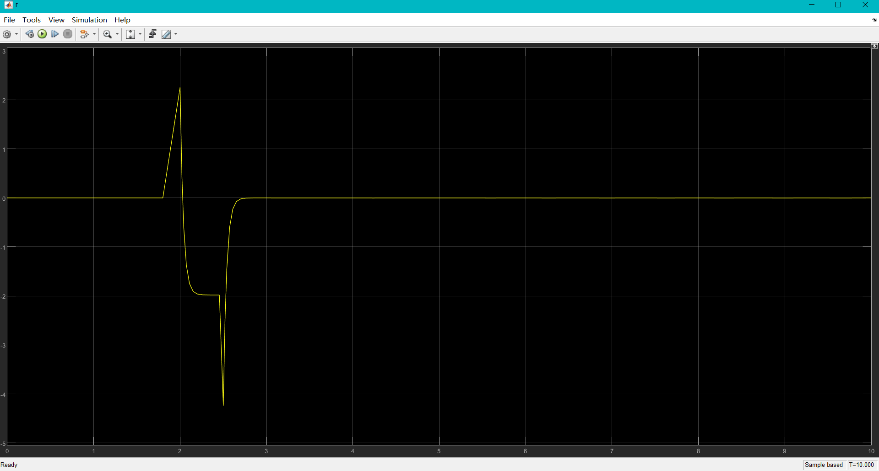

For scope1 and scope2 there exists mixed signal (f, d1, d2). Now, d1, d2 and f at same time (2s) However, diagram of r shows that d1 and d2 are reduced and f is enlarged after F. The fault can be isolated from disturbance by system. the disturbance at 2s will not be detected by the system but system detects fault at 2s.

**Experiment with difference scenarios to demonstrate the effectiveness of the FD algorithm.** Set fault: f = pulse at 2s with amplitude 2, disturbance: d1 = pulse at 4s, d2 = pulse at 5s. Amplitude of all disturbance signals are 3.

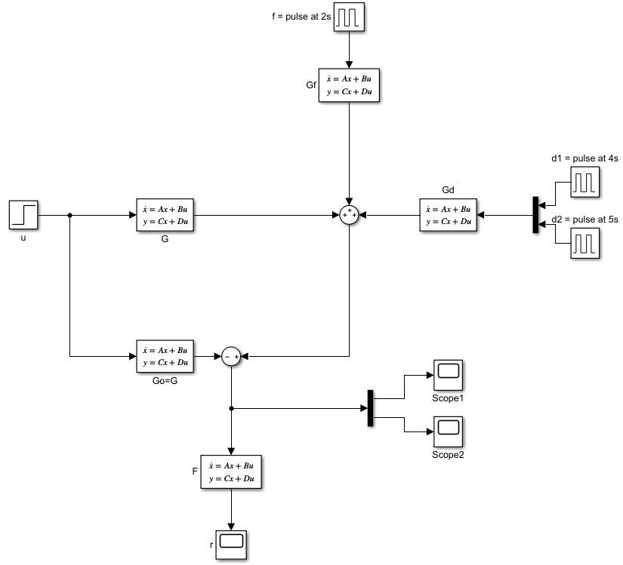

The scopes show that

Scope 1:

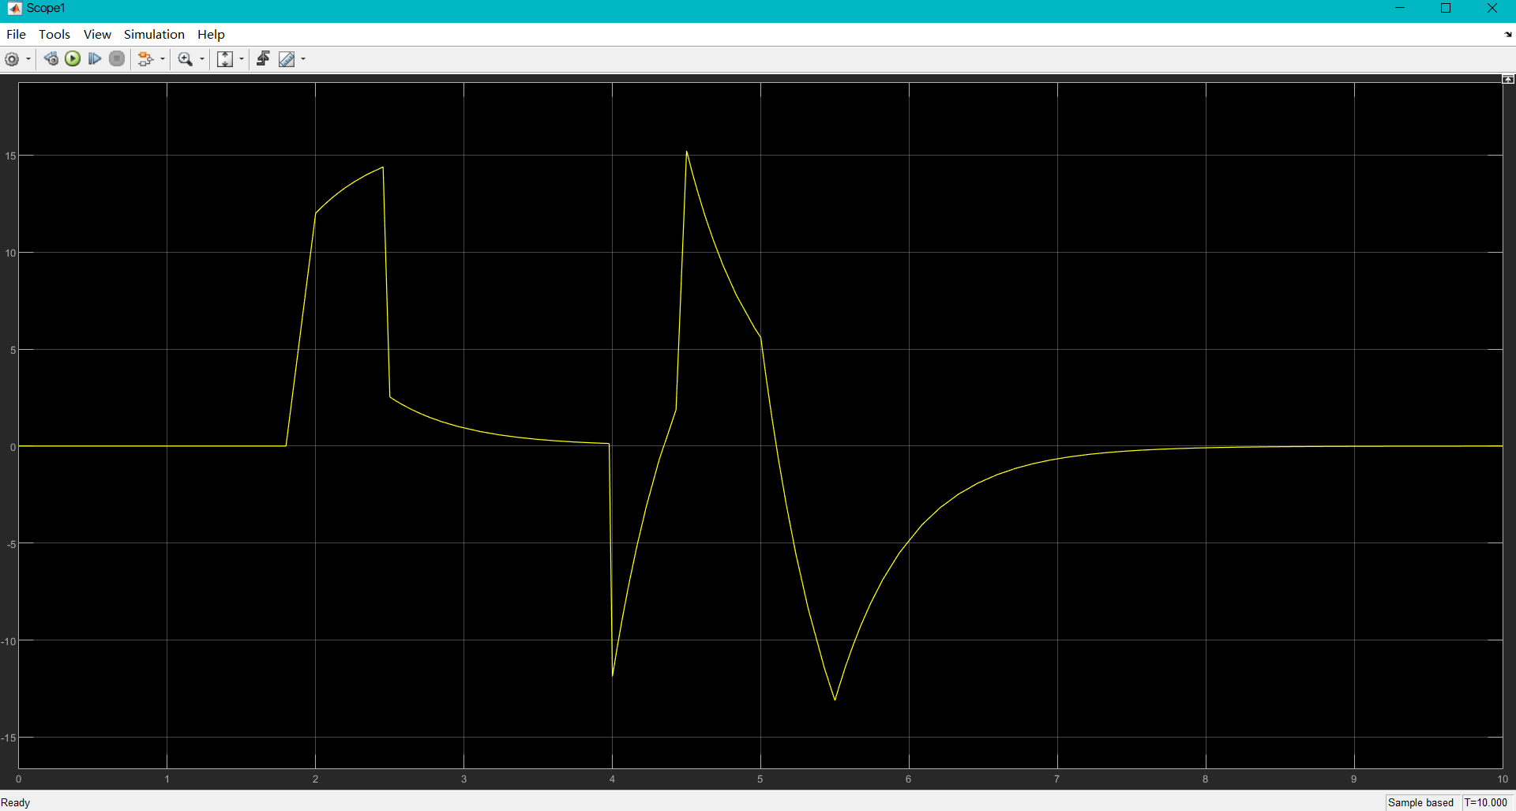

Scope 2:

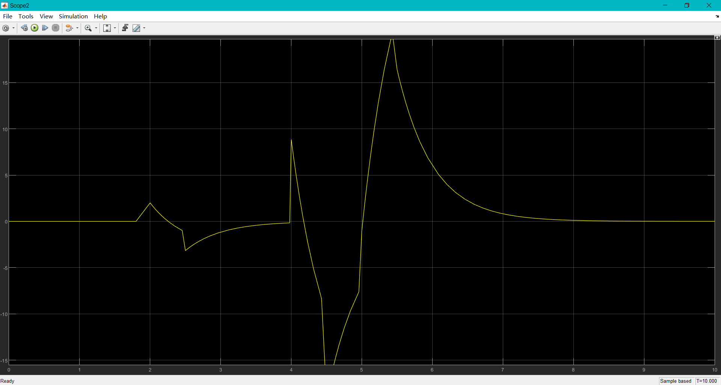

r(t):

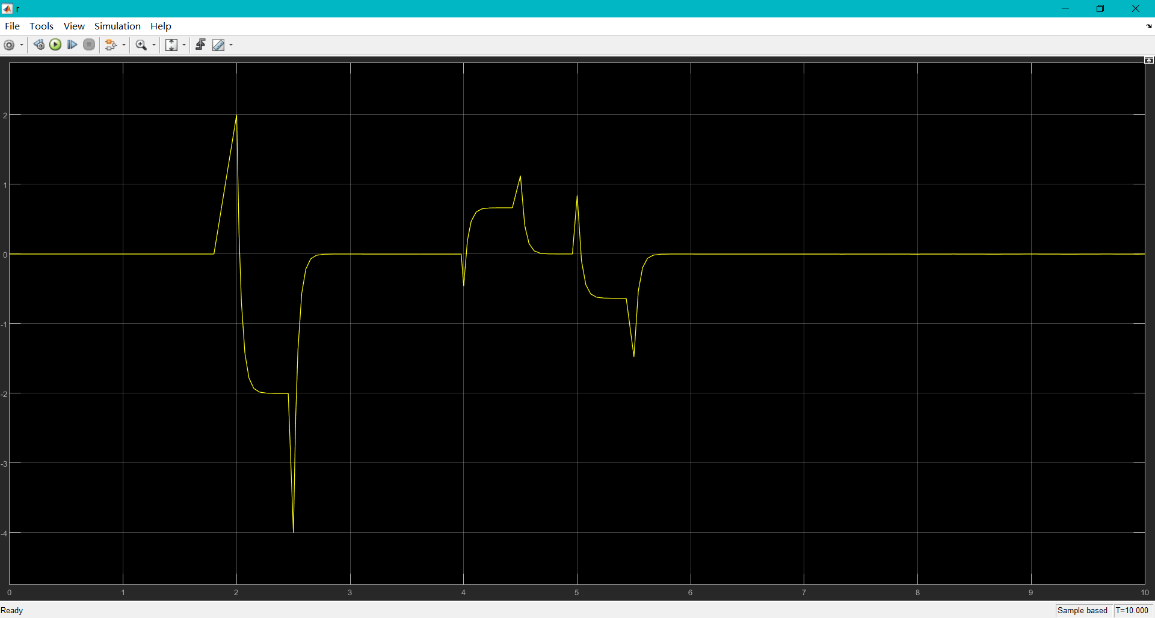

Scope1 and scope2 shows that the mixed signal exists. Although d1=d2=3 which is larger than f = 2, ‘r’ shows that d1 and d2 are reduced and f is enlarged at 2s after F. So, if we set detectable threshold at ±1.8, the disturbance at 4s and 5s will not be detected by the system. The diagram shows that there exists a fault at 2s. So, the system can detect the fault even if we change the occurs time of fault.

**Experiment with difference scenarios to demonstrate the effectiveness of the FD algorithm.** Set fault: f = pulse at 2s with amplitude 1, disturbance: d1 = pulse at 4s, d2 = pulse at 5s. Amplitude of all disturbance signals are 4.

Scope1:

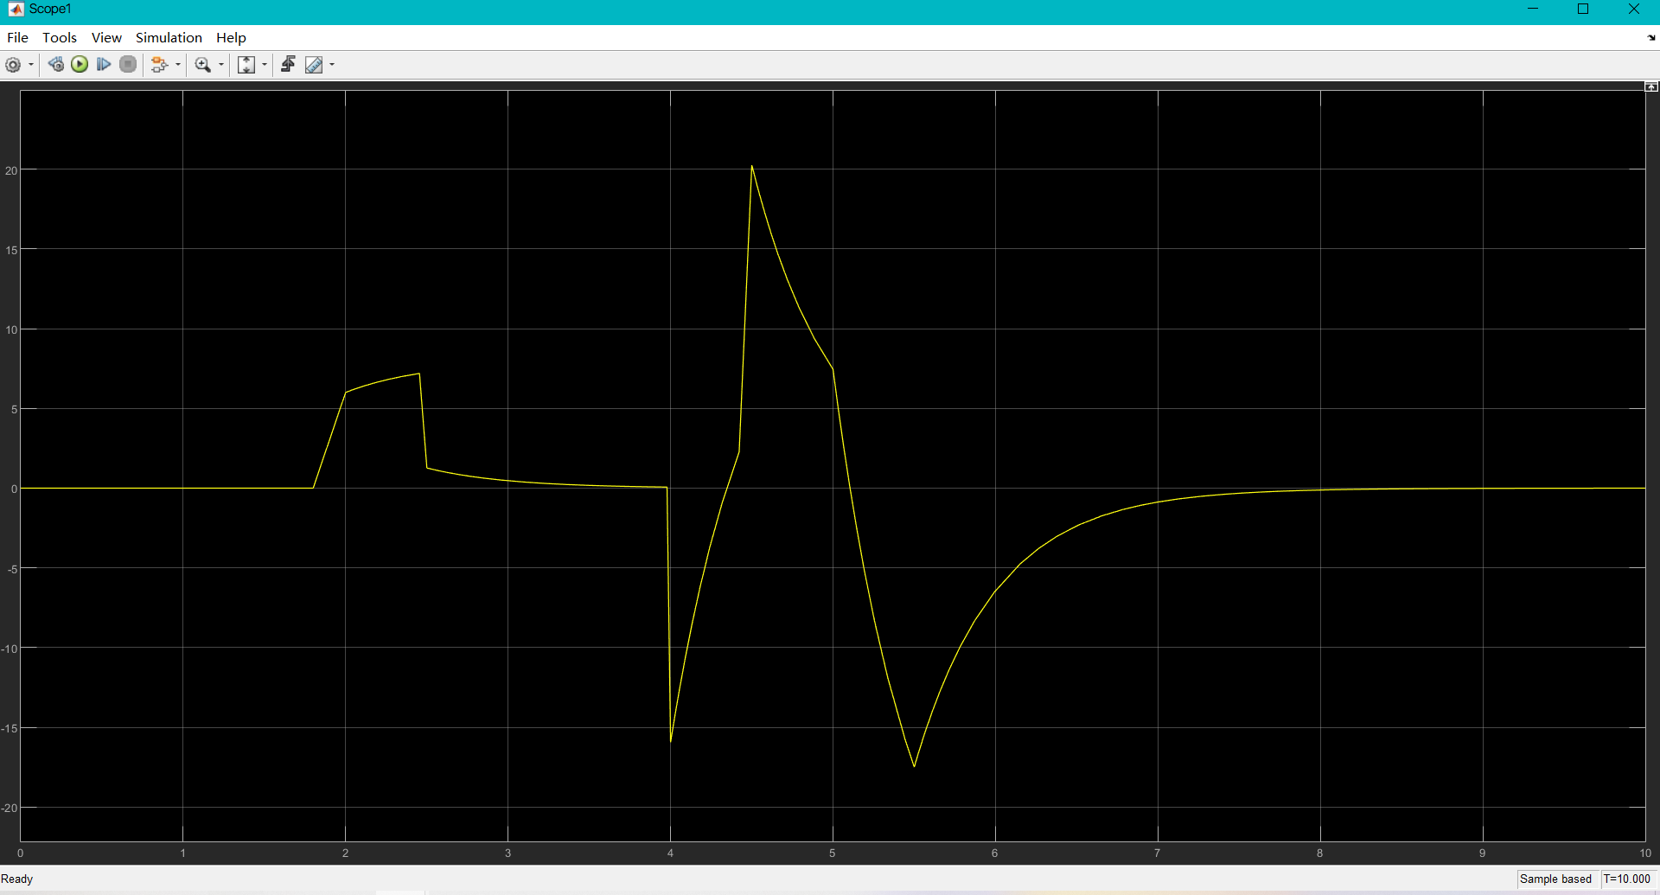

Scope2:

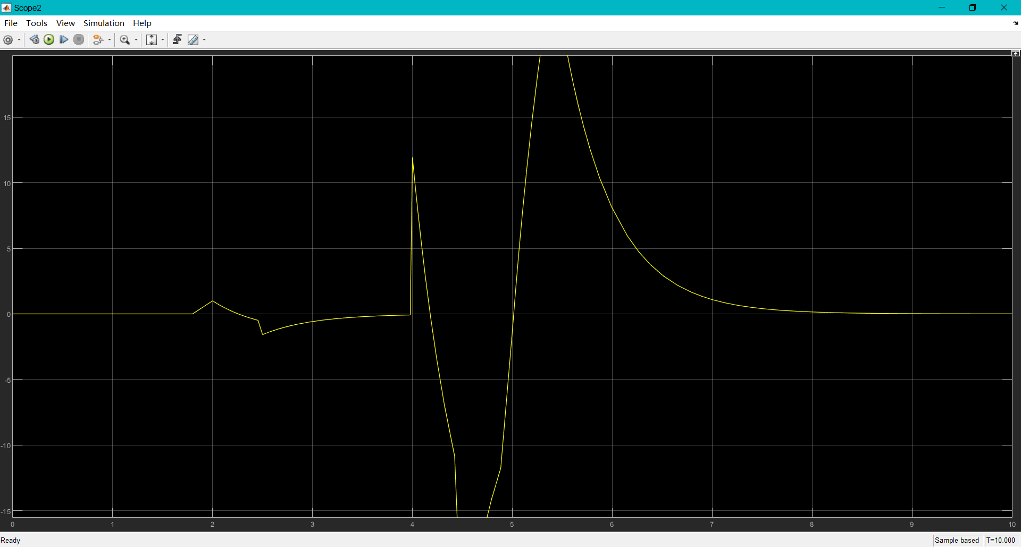

r(t):

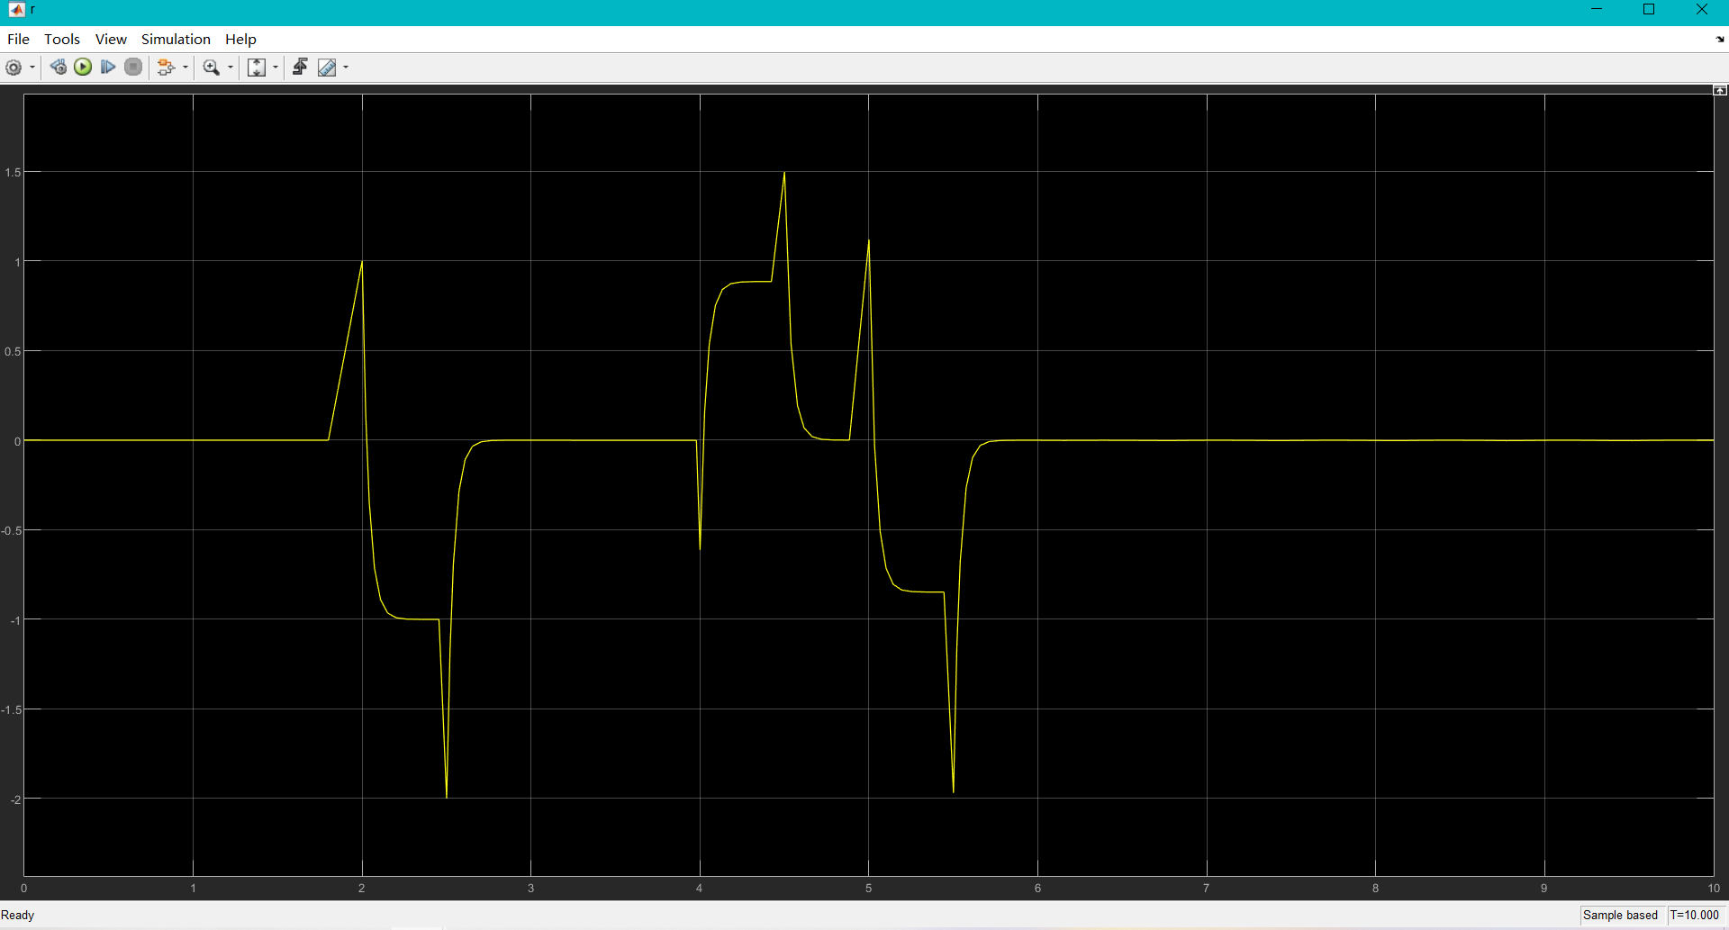

Scope1 and scope2 shows that the mixed signal exists. d1=d2=4 which is larger than f = 1, ‘r’ shows that d1 and d2 are reduced and f is enlarged at 2s after F. However, d1 and d2 are not reduced enough to distinguish from f. The amplitude of them are almost same, which is not able to detect the fault at 2s. So, we cannot set detectable threshold this time, the disturbance will also be detected by the system.

**Conclusion:**

Consider the difference scenarios to demonstrate the effectiveness of the FD algorithm.

when the amplitude of fault is larger or same as that of disturbance, the system will reduce the disturbance enough. When the amplitude of disturbance is little larger than that of fault, the system still works well, but the detectable threshold should be increased. However, when the amplitude of disturbance is larger than that of fault significantly, the system will not reduce the disturbance enough and the amplitude of disturbance will larger or equal than that of fault after the process of F, which means the system will not work well and will detect both disturbance and fault.

Under the condition of the detectable, the any occurs time of fault can be detected, when the disturbance and fault occurs at same time, the fault will be isolated by system.

4

**Appendix:**

(Matlab code)

clear;

A=-2;B=1;Bf=1;Bd=[4,-4];C=[4;-5];Df=[6;1];Dd=[-4,0;3,2];

n = 1;

nu = 1;

nf = 1;

nd = 2;

ny = 2;

[U,S,V] = svd(Df);

Dfd = V*(S(1)^-1)*U(:,1)';

Dfv = U(:,2)';

A1=A-Bf*Dfd*C;

B1=Bd-Bf*Dfd*Dd;

C1=Dfd*C;

C2=Dfv*C;

D1=Dfd*Dd;

D2=Dfv*Dd;

%% main calculation: use LMI solver to obtain P, Z, R, S, and gamma

setlmis([]);

g2 = lmivar(1,[1,1]);

P = lmivar(1,[n,1]);

Z = lmivar(2,[n,ny-nf]);

S = lmivar(2,[nf,ny-nf]);

L = newlmi;

lmiterm([L,1,1,P],1,A1,'s'); lmiterm([L,1,1,Z],1,C2,'s');

lmiterm([L,1,2,P],1,B1); lmiterm([L,1,2,Z],1,D2);

lmiterm([L,1,3,0],C1'); lmiterm([L,1,3,-S],C2',1);

lmiterm([L,2,2,g2],-0.5,1,'s');

lmiterm([L,2,3,0],D1'); lmiterm([L,2,3,-S],D2',1);

lmiterm([L,3,3,0],-1);

LMI = getlmis;

[g2,x] = mincx(LMI,eye(decnbr(LMI),1));

P = dec2mat(LMI,x,P);

Z = dec2mat(LMI,x,Z);

S = dec2mat(LMI,x,S);

gamma = sqrt(g2);

R = (P^-1)*Z;

%% L&H

H=Dfd+S*Dfv;

L=-Bf*Dfd+R*Dfv;

%% stable evaluation

if eig(A+L*C)<0

else

[X,Kp,Lp] = icare((A+L*C)',[],[],[],[],[],-(H*C)'*H*C);

LN=L-X*(H*C)'*H;

end